**Project 6 Coin Detection – Part 2 complete**

Name: ____Trisha Rayan_________________ Period: __7_________ Date: ___05/06/2021________

Did you name your file l062.cpp (Lower case L, then 062)? _yes___

Did you create the edge matrix? ___yes________

Did you create the gradient direction matrix? ___yes________

Did you create the imagev.ppm (visual of votes)? ___yes________

Did you use Bresenham's line algorithm for voting? ___yes________

Does your application create coins.ppm file? ___yes________

Does you code display on the screen and in results.txt a summary of your results? ___yes______

Did you test your code on terminal/gnu linux in c++11? ___yes______

Run your code (the same code you submit) on the 3 images I provided (easy, medium, hard) then paste here the following:

* The initial image ( the one I provided), the imagev.ppm, coins.ppm you obtained running your code, copy paste here the content of your results.txt file your code created

1. For the easy image:

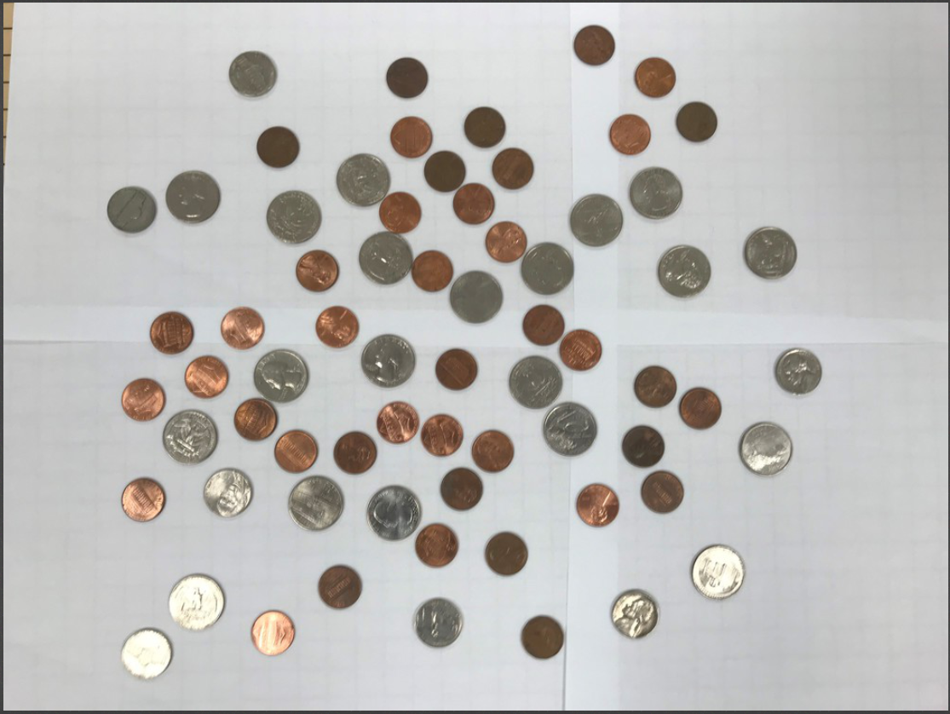

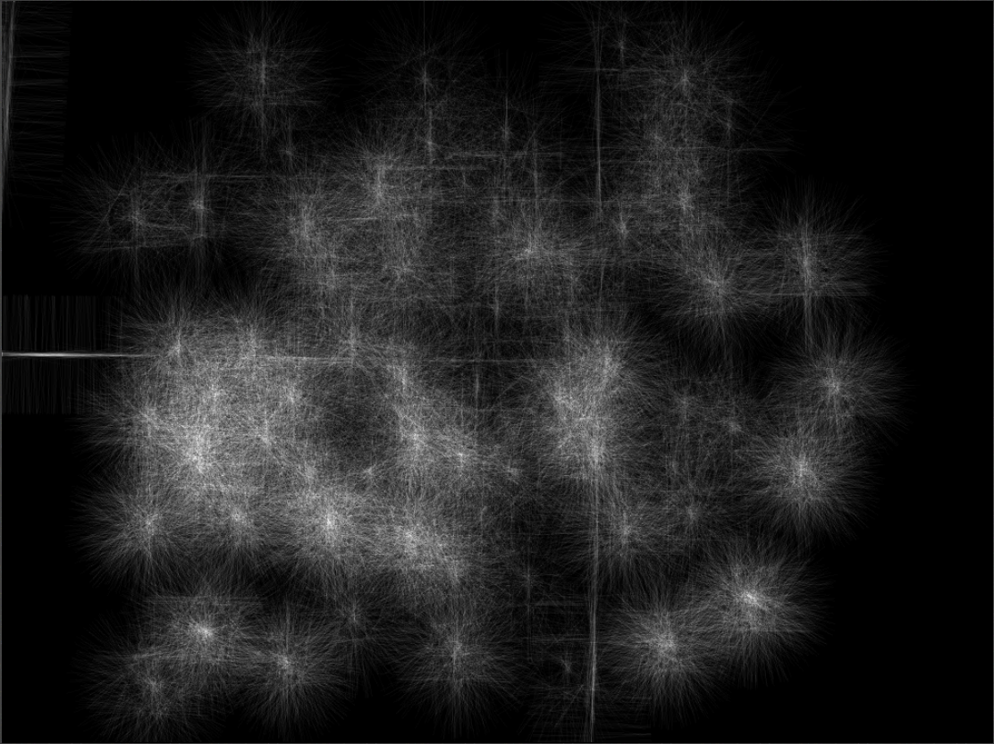

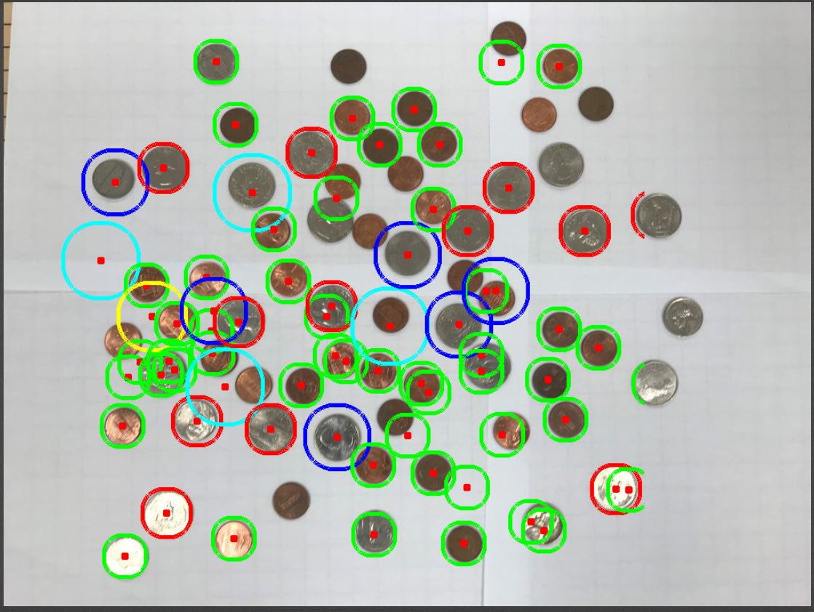

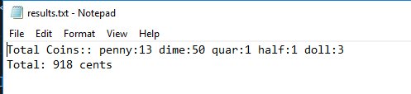

1. For the medium image:

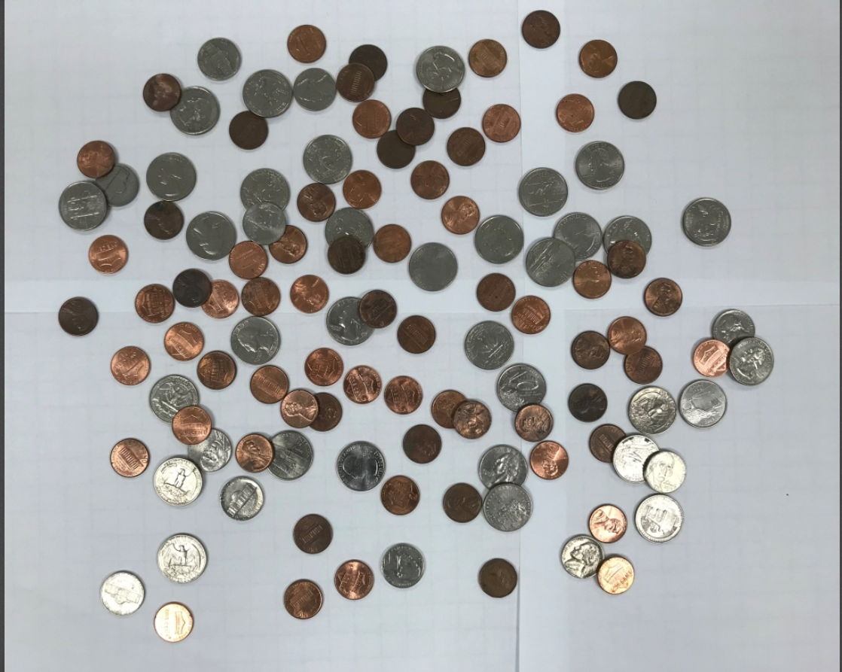

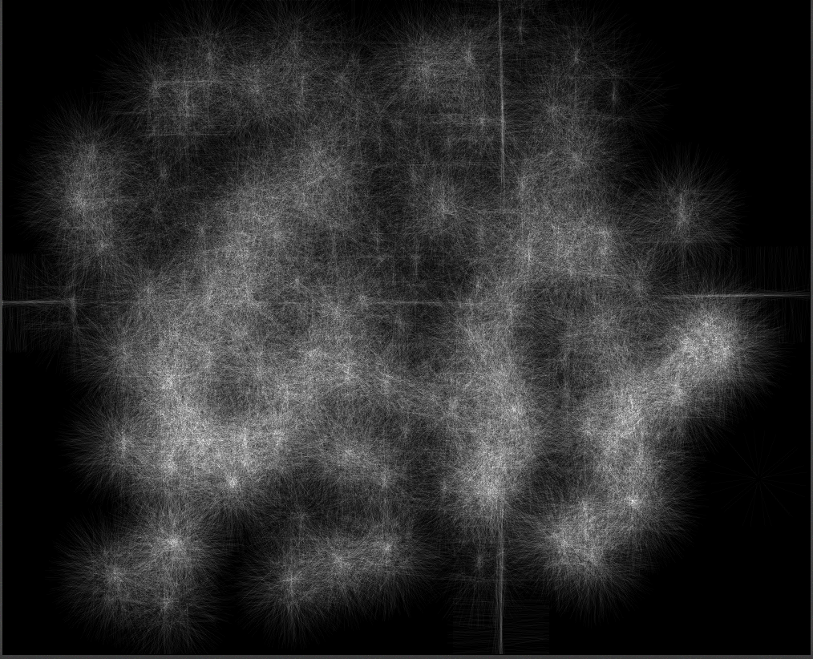

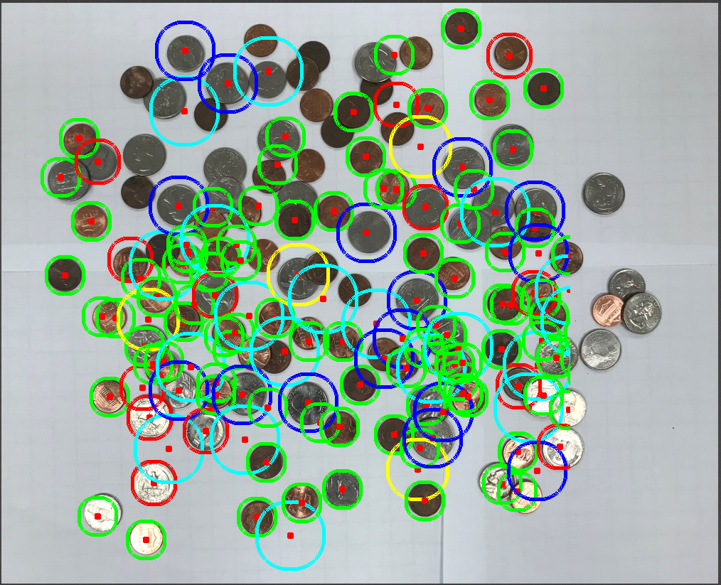

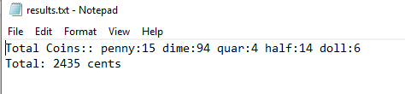

1. For the hard image

